**Question:**

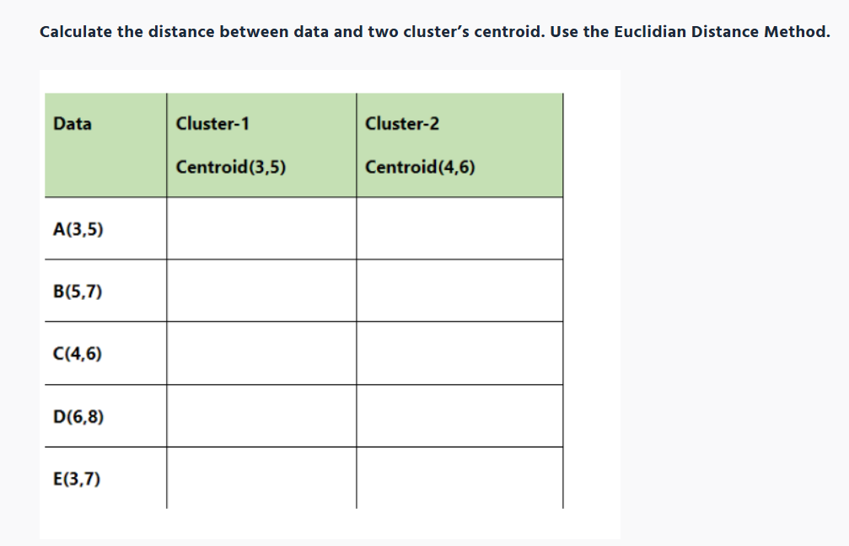

**Answer:**

The data points are A(3, 5), B(5, 7), C(4, 6), D(6, 8), and E(3, 7).

Centroid for cluster 1 is (3, 5) and centroid for cluster 2 is (4, 6).

We know,

Euclidean distance formula = sqrt((x1 - x2)^2 + (y1 - y2)^2)

Distance between A and Centroid 1 (3, 5):

= sqrt((3 - 3)^2 + (5 - 5)^2)

= sqrt(0 + 0)

= 0

Distance between B and Centroid 1 (3, 5):

= sqrt((5 - 3)^2 + (7 - 5)^2)

= sqrt(4 + 4)

= sqrt(8)

= 2.82 (approx)

Distance between C and Centroid 1 (3, 5):

= sqrt((4 - 3)^2 + (6 - 5)^2)

= sqrt(1 + 1)

= sqrt(2)

= 1.41 (approx)

Distance between D and Centroid 1 (3, 5):

= sqrt((6 - 3)^2 + (8 - 5)^2)

= sqrt(9 + 9)

= sqrt(18)

= 4.24 (approx)

Distance between E and Centroid 1 (3, 5):

= sqrt((3 - 3)^2 + (7 - 5)^2)

= sqrt(0 + 4)

= sqrt(4)

= 2

Distance between A and Centroid 2 (4, 6):

= sqrt((3 - 4)^2 + (5 - 6)^2)

= sqrt(1 + 1)

= sqrt(2)

= 1.41 (approx)

Distance between B and Centroid 2 (4, 6):

= sqrt((5 - 4)^2 + (7 - 6)^2)

= sqrt(1 + 1)

= sqrt(2)

= 1.41 (approx)

Distance between C and Centroid 2 (4, 6):

= sqrt((4 - 4)^2 + (6 - 6)^2)

= sqrt(0 + 0)

= 0

Distance between D and Centroid 2 (4, 6):

= sqrt((6 - 4)^2 + (8 - 6)^2)

= sqrt(4 + 4)

= sqrt(8)

= 2.82 (approx)

Distance between E and Centroid 2 (4, 6):

= sqrt((3 - 4)^2 + (7 - 6)^2)

= sqrt(1 + 1)

= sqrt(2)

= 1.41 (approx)

The data points are A(3, 5), B(5, 7), C(4, 6), D(6, 8), and E(3, 7).

Centroid for cluster 1 is (3, 5) and centroid for cluster 2 is (4, 6).

We know,

Euclidean distance formula = sqrt((x1 - x2)^2 + (y1 - y2)^2)

Distance between A and Centroid 1 (3, 5):

= sqrt((3 - 3)^2 + (5 - 5)^2)

= sqrt(0 + 0)

= 0

Distance between B and Centroid 1 (3, 5):

= sqrt((5 - 3)^2 + (7 - 5)^2)

= sqrt(4 + 4)

= sqrt(8)

= 2.82 (approx)

Distance between C and Centroid 1 (3, 5):

= sqrt((4 - 3)^2 + (6 - 5)^2)

= sqrt(1 + 1)

= sqrt(2)

= 1.41 (approx)

Distance between D and Centroid 1 (3, 5):

= sqrt((6 - 3)^2 + (8 - 5)^2)

= sqrt(9 + 9)

= sqrt(18)

= 4.24 (approx)

Distance between E and Centroid 1 (3, 5):

= sqrt((3 - 3)^2 + (7 - 5)^2)

= sqrt(0 + 4)

= sqrt(4)

= 2

Distance between A and Centroid 2 (4, 6):

= sqrt((3 - 4)^2 + (5 - 6)^2)

= sqrt(1 + 1)

= sqrt(2)

= 1.41 (approx)

Distance between B and Centroid 2 (4, 6):

= sqrt((5 - 4)^2 + (7 - 6)^2)

= sqrt(1 + 1)

= sqrt(2)

= 1.41 (approx)

Distance between C and Centroid 2 (4, 6):

= sqrt((4 - 4)^2 + (6 - 6)^2)

= sqrt(0 + 0)

= 0

Distance between D and Centroid 2 (4, 6):

= sqrt((6 - 4)^2 + (8 - 6)^2)

= sqrt(4 + 4)

= sqrt(8)

= 2.82 (approx)

Distance between E and Centroid 2 (4, 6):

= sqrt((3 - 4)^2 + (7 - 6)^2)

= sqrt(1 + 1)

= sqrt(2)

= 1.41 (approx)